SharePoint Live Code

SharePoint Live Code allows for "on-the-fly" C # or Javascript source code execution.

SharePoint Live Code consists of a WebPart and two Template Codes, one for the C # and one for the Javascript.

To get started with SharePoint Live Code you have to:

1. Install the WebPart SharePointLiveCode.wsp in the SharePoint Farm
2. Create 2 document library to use as the source code repository.

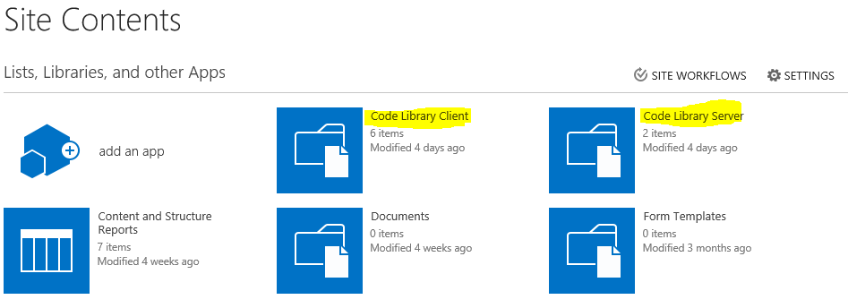

We recommend using 2 document libraries to better manage access permissions.

The first document library will be used to manage Client code (Javascript), break inheritance, read-only to all users, read / write to administrators and developers.

The second document library will serve to manage the Server (C #) code, break inheritance, block access to all users except for WebApplication pool administrators, developers, and users who will have read / write (the Code runs with RunWithPrivilege). This step is essential to prevent unauthorized users from seeing the source code.

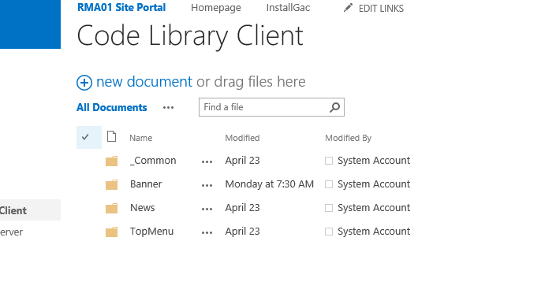

In the _Common Folder you can put all common cross component Javascript to load before the component itself.

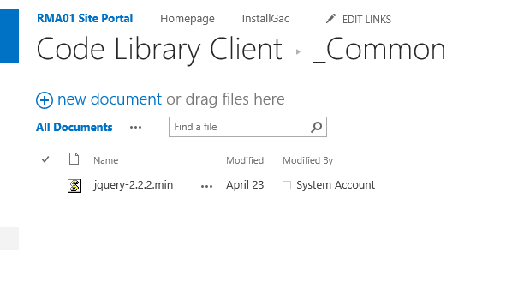

For example, jQuery.

1. Create a page and insert the WebPart from the gallery (located in the "SharePoint Live Code" group)

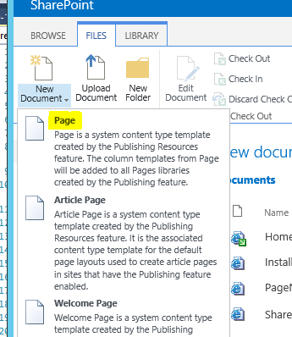

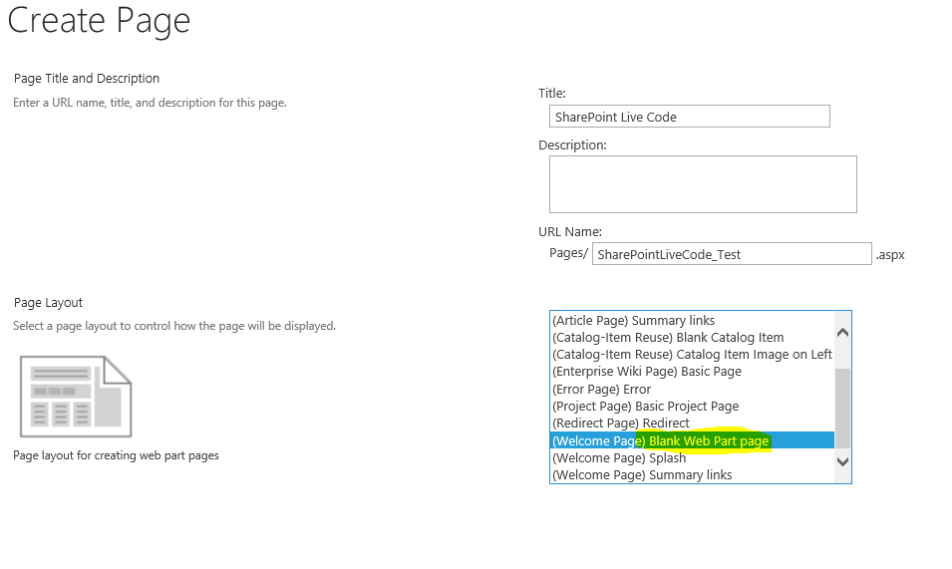

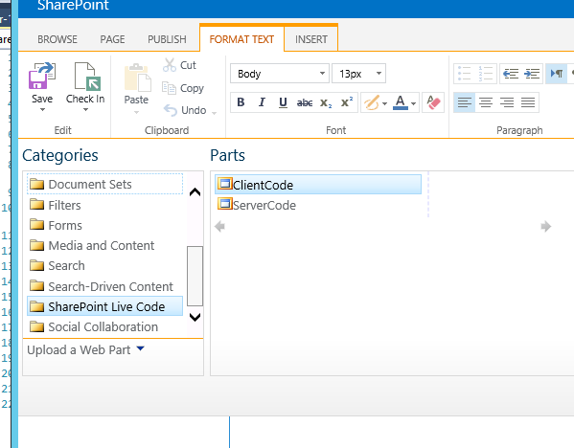

Select the WebPart ClientCode if you only want to use client code (Javascript).

Select the WebPart ServerCode if you want to use client code (Javascript) and / or server side (C #).

1. Select WebPart edit

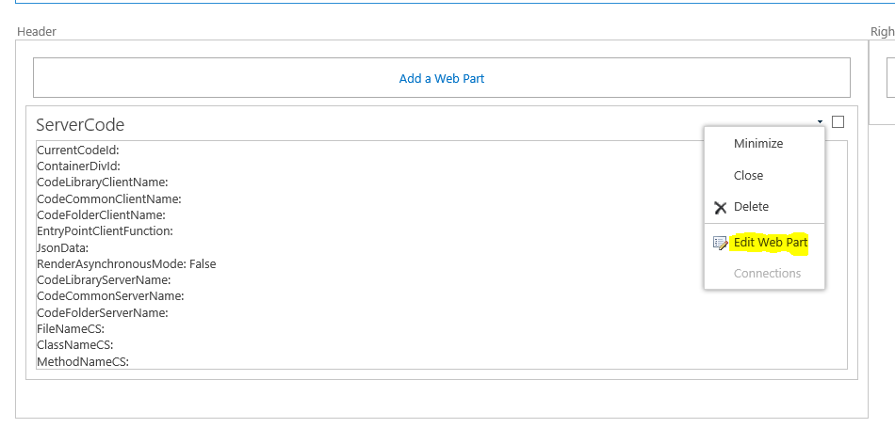

1. Import the CustomProperties of the following categories:

Generic Properties

Client Properties

Server Properties

Data Properties

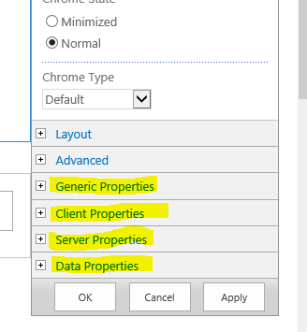

**Generic Properties**

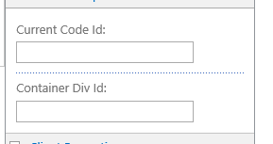

Current Code Id: is a unique code that will identify the WebPart on the page and is useful if you want to run the same Code multiple times on the page.

Container Div Id: is the name of the div in which will be inserted all the component code to run "on the fly"

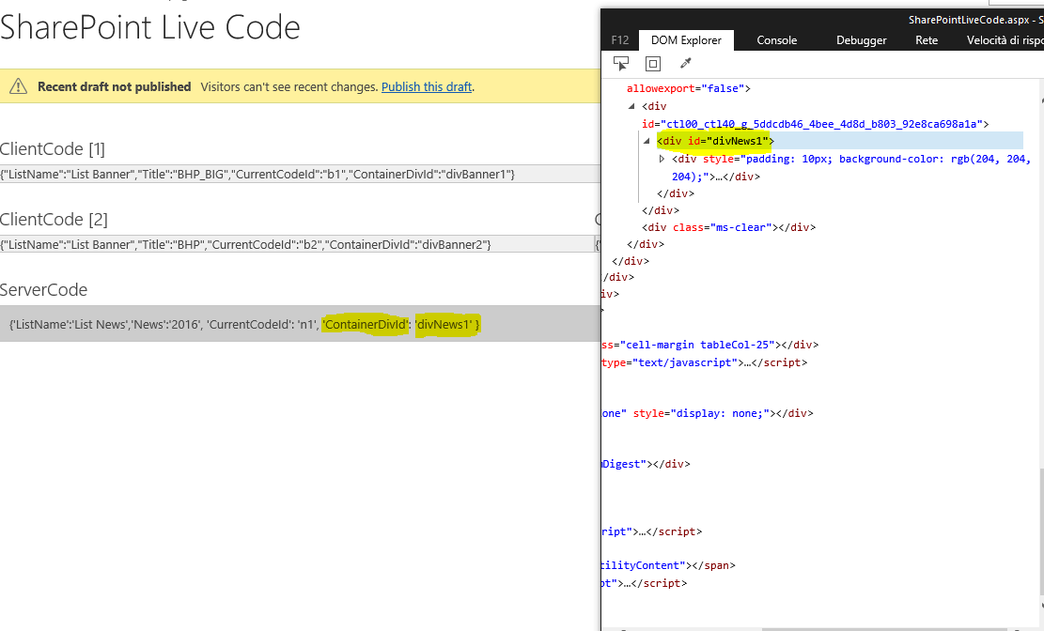

**Client Properties**

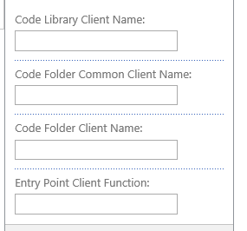

Code Library Client Name: is the name of the Document Library from which the client scripts will be loaded.



Code Folder Common Client Name: This is the folder name that contains the Client Cross Application side code, such as jQuery



Code Folder Client Name: is the name of the folder that contains the Client side code to run "on the fly"

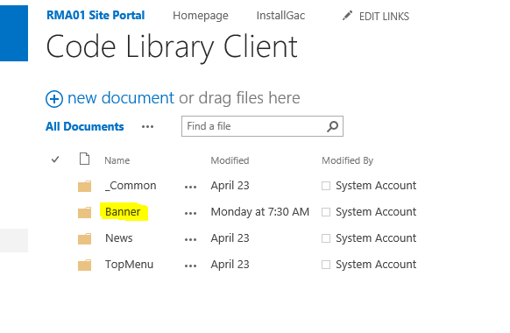

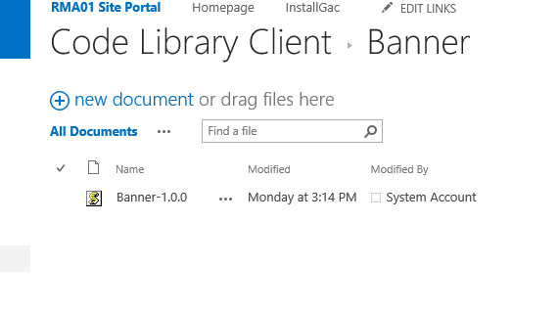

Entry Point Client Function: This is the name of the "main" function to execute to initialize the component.

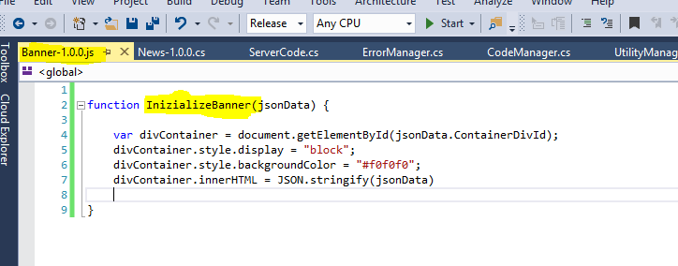

**Server Properties**

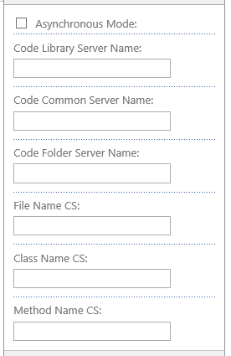

Asynchronous Mode: Not Implemented in Version 1.0.0

Code Library Server Name: is the name of the Document Library from which the Server scripts will be loaded.

Code Folder Common Sever Name: is the name of the folder containing the Server side code Cross Application (CAUTION not implemented in version 1.0.0)

Code Folder Server Name: This is the folder name that contains the Client Side Server side to run "on the fly"

File Name CS: is the name of the CS file to run:

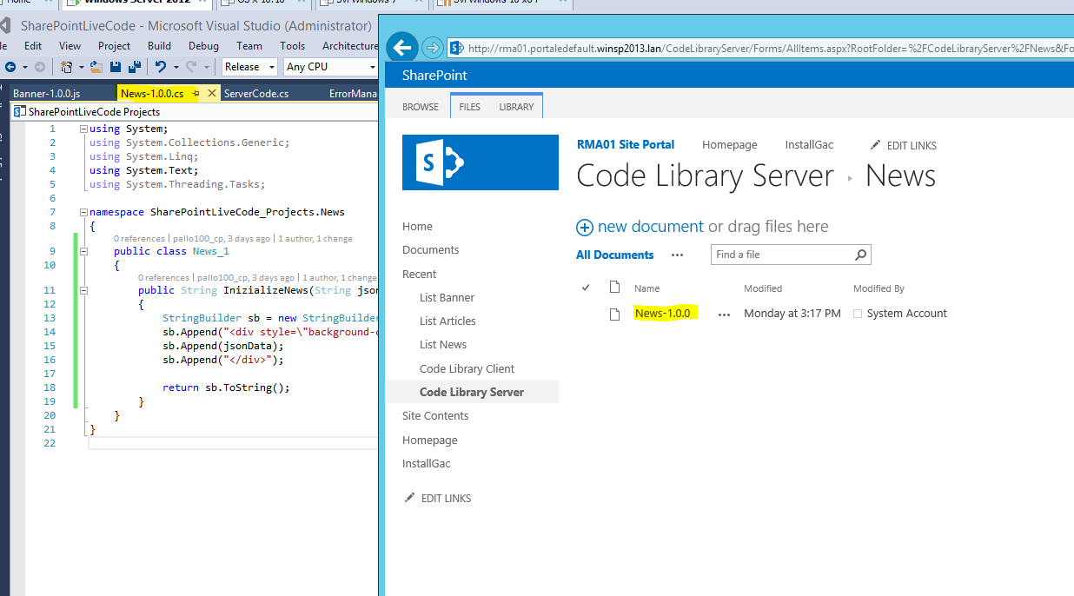

Class Name CS: is the name of the Inclusive Class of the NameSpace (in the example is SharePointLiveCode_Projects.News.News_1)

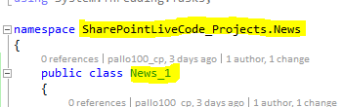

Method Name CS: is the name of the Main method to run (in the example is InizializeNews)

**Data Properties**

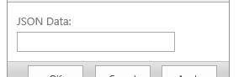

JSON Data: It is a json structure to pass any parameter set an example {'ListName':'List News','News':'2016'}

This data is passed to the main Client and Server side functions

